ALL INDIA INSURANCE EMPLOYEES’ ASSOCIATION
LIC BUILDING SECRETARIAT ROAD HYDERABAD 500063
Email: aiieahyd@gmail.com

PRESIDENT: Phone: 040-23244595
AMANULLA KHAN
GENERAL SECRETARY:
V. RAMESH

11th October, 2015.
To
All the Secretariat Members of AIIEA,
NOTICE
-is hereby given that an urgent meeting of the Secretariat of All India Insurance Employees’ Association will be held at Mumbai on 16th October, 2015 at 2.30 pm to transact the following agenda:

- To review the developments on wage revision in LIC and take the appropriate decisions
- Organizational matters &
- Any other matter with the permission of the Chair
All the Secretariat Members of the AIIEA are requested to attend without fail.

Comradely yours,
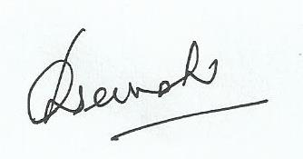
General Secretary.
PS: Information regarding the venue of the meeting will be informed shortly.

