ALL INDIA INSURANCE EMPLOYEES’ ASSOCIATION
LIC BUILDING SECRETARIAT ROAD HYDERABAD 500063
Email: aiieahyd@gmail.com

PRESIDENT: Phone: 040-23244595
AMANULLA KHAN
GENERAL SECRETARY:
V. RAMESH
01-08-2015
To
All the Zonal General Secretaries in Life Sector
Dear Comrades,
Letter to Chairman and Circular to Officers and Employees

We write to inform you that after the Joint Meeting of Unions held at Mumbai on 28th July, 2015 an agitation programme was decided. The same was communicated to you by a message on even date. As per the decision of the joint meeting, a letter is addressed to Chairman demanding for an early and satisfactory settlement of wage revision and one more option for Pension. We attach herewith the letter addressed to Chairman signed by all unions.
We also attach a circular addressed to officers and employees regarding the agitation programme.
We request you to guide all the divisional units to implement the agitation programme successfully. Regarding the 5th August 2015 programme, please advise all divisional units to handover copies of letter addressed to the Chairman and the above said circular to the Sr. Divisional Manager after the lunch hour demonstrations. Please ensure that one representative from each union will be part of the delegation when they meet the Sr. Divisional Manager.
The joint meeting also decided to meet again on 19.8.2015 at Mumbai to decide further programme of action.
With greetings,

Comradely yours,
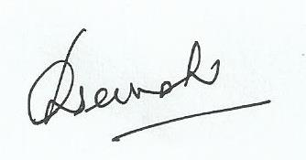
General Secretary.
PS: We confirm that today at 1.pm the delegation of joint unions handed over the letter addressed to Chairman to Managing Director at ‘Yogakshema’ as the Chairman was not available.

