ALL INDIA INSURANCE EMPLOYEES’ ASSOCIATION
LIC BUILDING SECRETARIAT ROAD HYDERABAD 500063
Email: aiieahyd@gmail.com

PRESIDENT: Phone: 040-23244595
AMANULLA KHAN
GENERAL SECRETARY:
V. RAMESH

30.06.2015

Chairman,
LIC of India,
Central Office,
Mumbai.

Dear Sir,

This has the reference to the mail dated 29.6.2015 from Executive Director (Personnel) appealing us for withdrawal of the proposed strike on 8th July, 2015 on the long pending issues - Wage Revision which is due from 01.8.2012 and one more option for pension.

In response to the mail we write to inform you that we have decided to defer the proposed strike action on 8th July, 2015, on the assurance that ‘LIC management is in active discussions with the Govt. to finalise the wage settlement at the earliest’.

We hope that the management will invite us for negotiations at the earliest to give a solution to the above long pending demands of the employees.

Thanking you,

Yours faithfully,

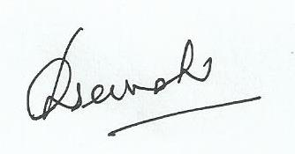
General Secretary.

