ALL INDIA INSURANCE EMPLOYEES’ ASSOCIATION
LIC BUILDING SECRETARIAT ROAD HYDERABAD 500063
Email: aiieahyd@gmail.com

PRESIDENT: Phone: 040-23244595
AMANULLA KHAN
GENERAL SECRETARY:
V. RAMESH
17th April, 2015.
To
All Zonal General Secretaries &
Secretary, Standing Committee (GI)

Dear Comrades,
Express Solidarity to BSNL Employees’ Strike
BSNL Casual and Contract Workers’ Federation issued strike notice to the BSNL management and DoT for strike on 21 and 22nd April, 2015. The Forum of BSNL Unions/Associations has given call for two days strike during the same days.
The strike call is given to “SAVE BSNL, SAVE NATION” and to revive the public sector BSNL. The employees while deploring the attitude of management/government are demanding to take necessary steps for procuring sufficient equipment to improve the service and paving way for expansion and development of this public sector.
Apart from the above demand the employees are also demanding the regularization of left out casual labour and contract workers and implementation of social security measures like EPF, ESI, and Gratuity etc. to these workers.
AIIEA while extending its solidarity to the two days strike of BSNL employees on 21st and 22nd April, 2015 urges the BSNL management to respond positively to the demands of the employees.
We call upon all our units to extend support to the BSNL employees’ strike rally across the country in coordination with BSNL Unions/Associations.
With greetings,
Comradely yours,
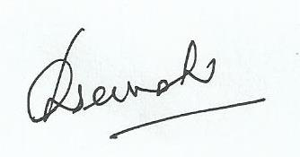
General Secretary.

