ALL INDIA INSURANCE EMPLOYEES’ ASSOCIATION
LIC BUILDING SECRETARIAT ROAD HYDERABAD 500063
Email: aiieahyd@gmail.com

PRESIDENT: Phone: 040-23244595
AMANULLA KHAN
GENERAL SECRETARY:
V. RAMESH

31st March, 2015.
To
All the Zonal General Secretaries,

Dear comrades,
Re: Group Mediclaim policy – cashless facility through TPAs.
You are aware that AIIEA was demanding for the cashless Medical facility to in-service and retired employees of LIC and their dependents. The cashless Medical facility is very important in the background particularly after the introduction of a floater policy along with an option of higher sum assured from last year.
Now, the Central Office communicated to all the zones that the Group Mediclaim Policy for the year 2015-16 has been renewed with New India Assurance Co. Ltd. with cashless facility for all diseases and treatments covering employees/retired employees and their dependents through TPAs.
Kindly follow up with your respective zonal managements for further details.
With greetings,

Comradely yours,
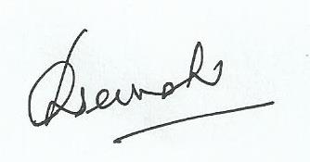
General Secretary.

