ALL INDIA INSURANCE EMPLOYEES’ ASSOCIATION
LIC BUILDING SECRETARIAT ROAD HYDERABAD 500063
Email: aiieahyd@gmail.com

PRESIDENT: Phone: 040-23244595
AMANULLA KHAN 040-23244596
GENERAL SECRETARY: Fax: 040-23244597
V. RAMESH
31.01.2014
Executive Director (Personnel),
LIC of India,
Central Office, Mumbai.

Dear Sir,
Information Sharing Session at Mumbai on 13th and 14th February 2014

This is with reference to your letter dated 30th January 2014 on the above subject.

We presume that there would be a joint session on the first day followed by an individual session with each union/association.

We wish to inform you that in the joint session AIIEA will be represented by the following office-bearers.
V. RAMESH | GENERAL SECRETARY | HYDERABAD | REACHING ON 12-02-2014 NIGHT | LEAVING ON 14-02-2014 NIGHT
K VENU GOPAL | VICE PRESIDENT | HYDERABAD | REACHING ON 12-02-2014 NIGHT | LEAVING ON 14-02-2014 NIGHT
H.I. BHATT | JOINT SECRETARY | GANDHINAGAR | REACHING ON 12-02-2014 NIGHT | LEAVING ON 14-02-2014 NIGHT

As informed to you, Shri Amanulla Khan, President, AIIEA will join the individual discussion on 14-02-2014
AMANULLA KHAN | PRESIDENT | BENGALURU | REACHING ON  13-02-2014 | LEAVING ON 14-02-2014 NIGHT

This is for your information.

Yours faithfully,
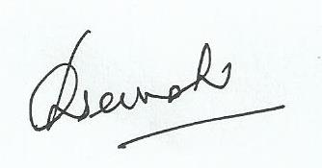
(V. Ramesh)
General Secretary.

